HR Workforce Attrition Analysis

Domain : Data Analytics + HR Analytics + Workforce Intelligence
Difficulty : Intermediate Industry Focus: Human Resources / People Analytics : Workforce Management / Business Intelligence
Skills Covered : KPI Design, Dashboard Development, Employee Segmentation, Trend Analysis, Root Cause Analysis, Data Storytelling
Topic : IBM HR Analytics

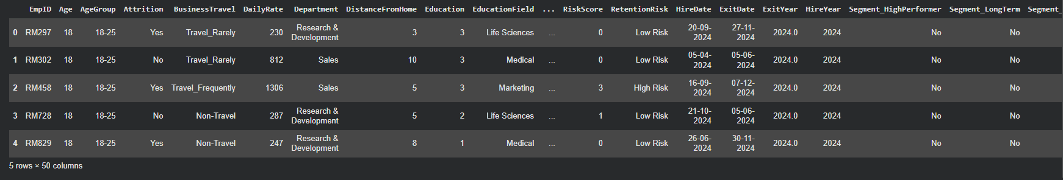
Phase 1: Data Understanding & Cleaning

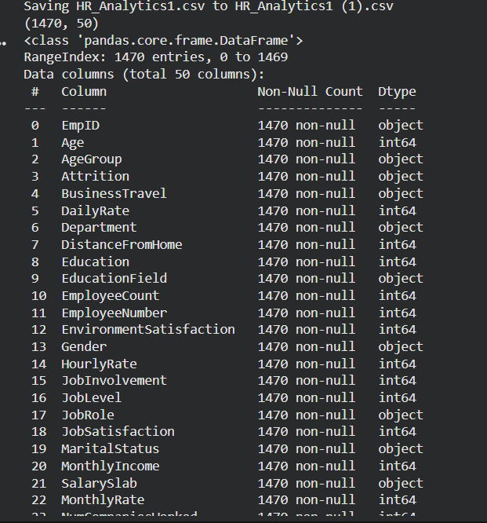
STEP-1 : Understand the Variable

STEP -2 : Handle missing values
STEP-3 : Remove duplicates
STEP-4 : Create derived variable
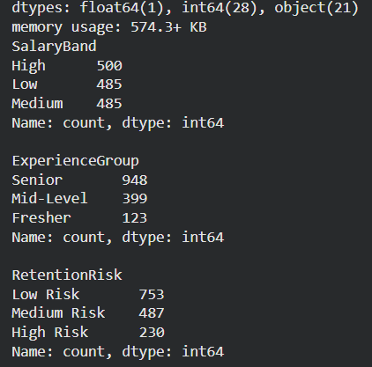

Phase 2: KPI Design
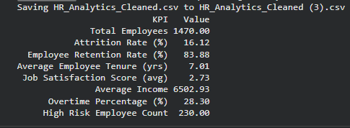
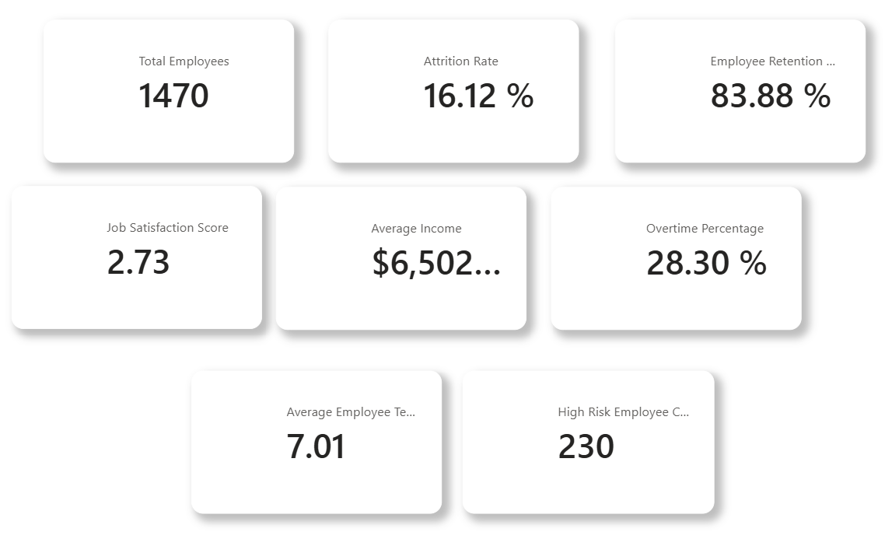
Phase 3: Analytics Investigation
Department vs Attrition
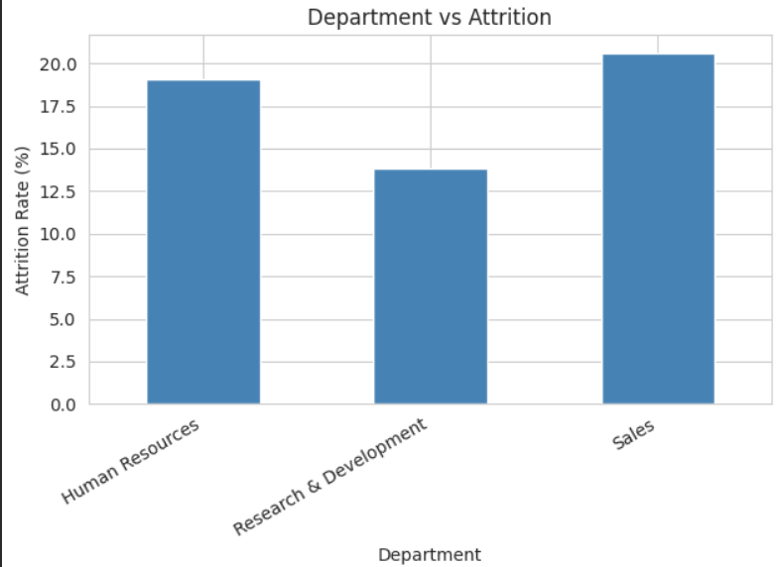
Job Satisfaction vs Attrition
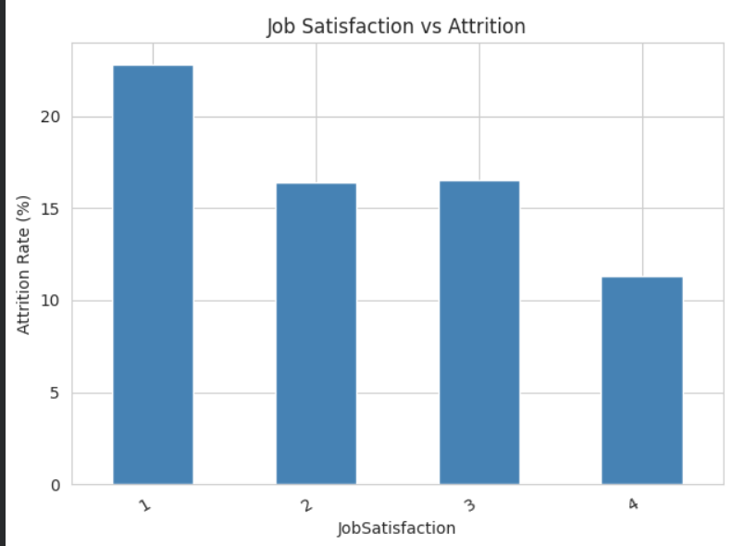
Salary vs Attrition
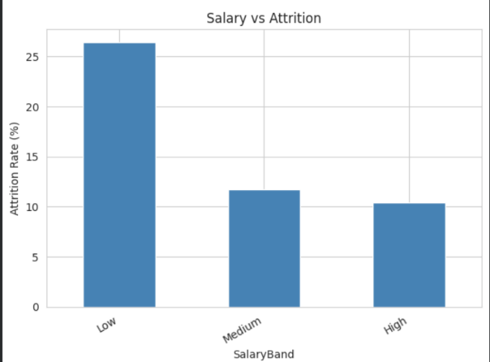
Work-Life Balance vs Attrition
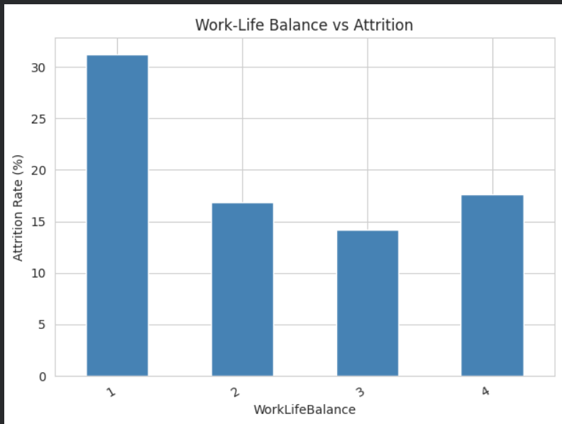
Overtime vs Attrition
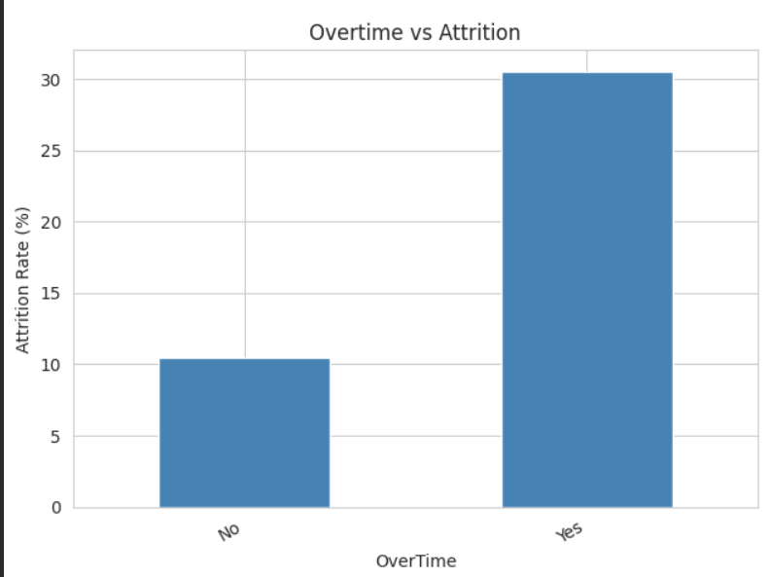
ATTRITION RISK FUNNEL

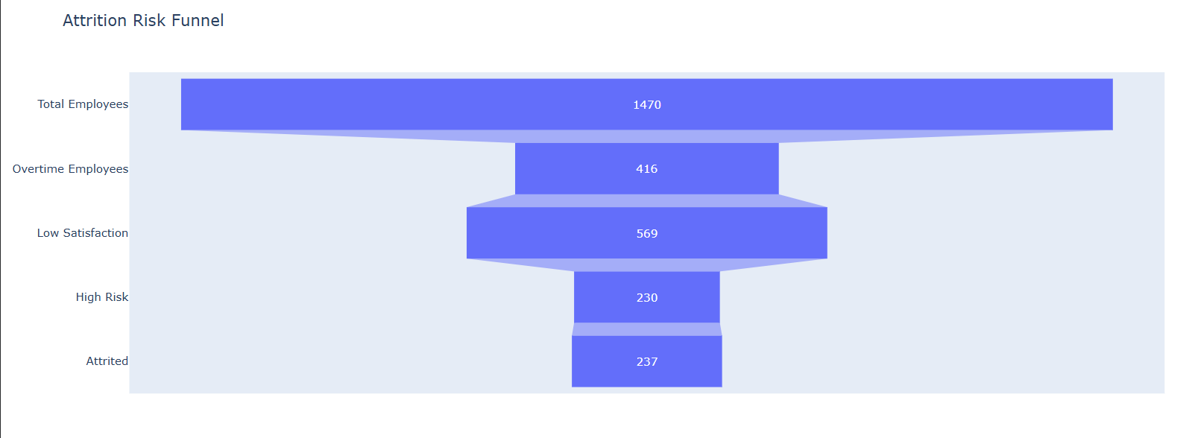
CORRELATION HEATMAP
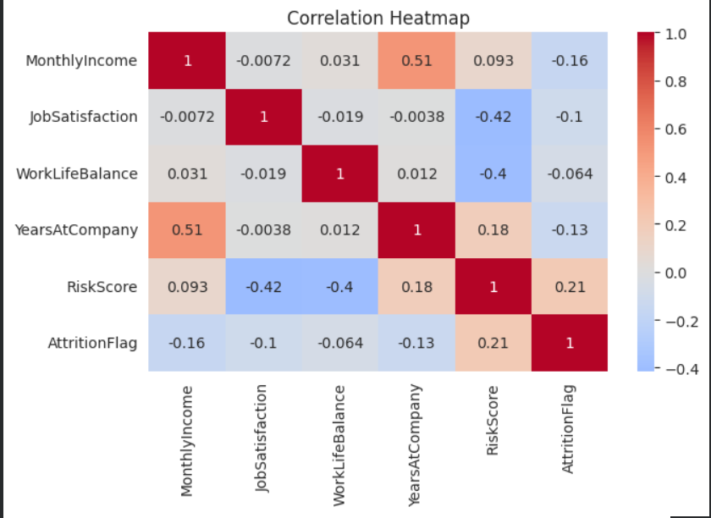

TREND CHART

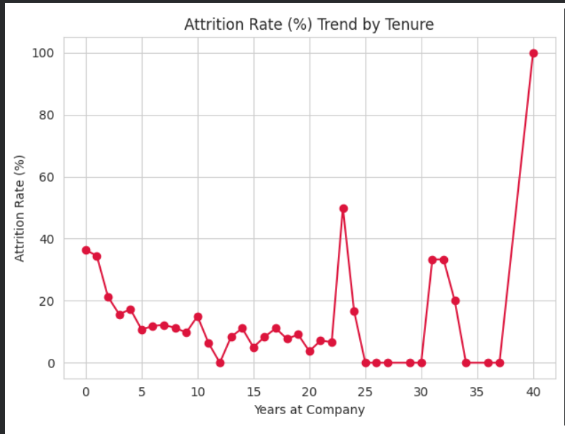

Phase 4: Employee Segmentation
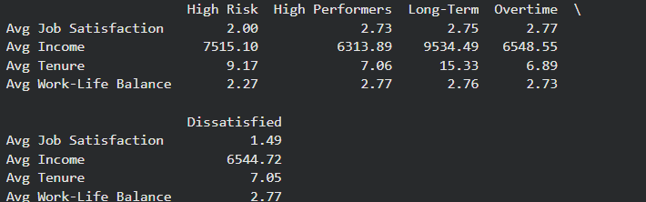

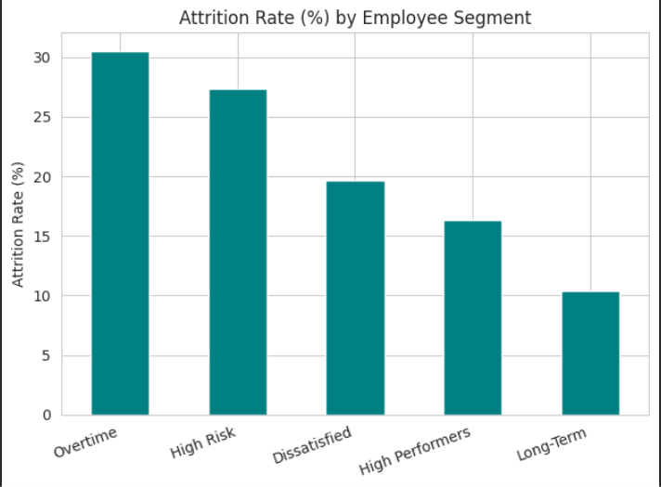

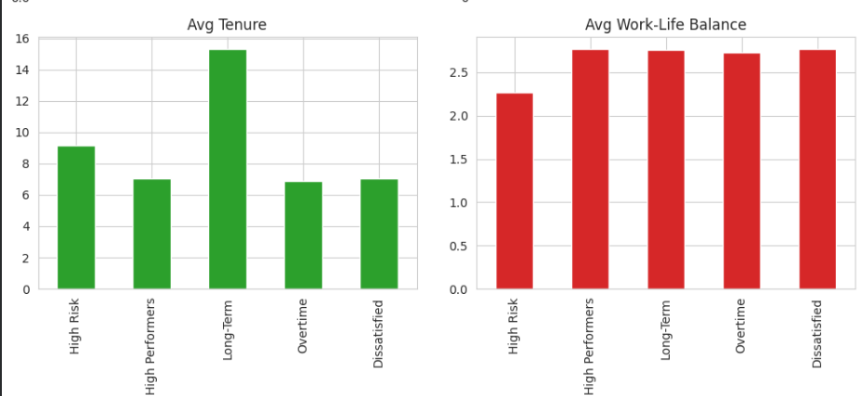

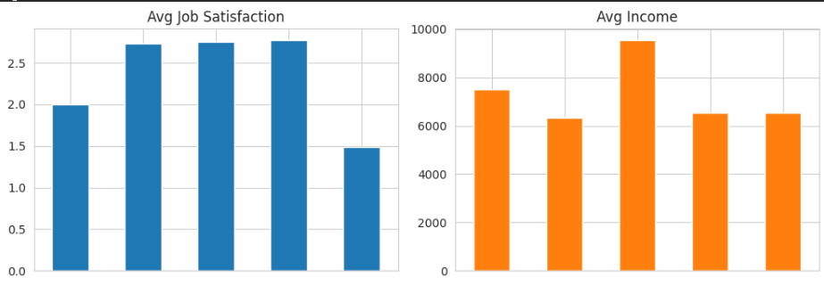

Phase 5: Dashboard Development

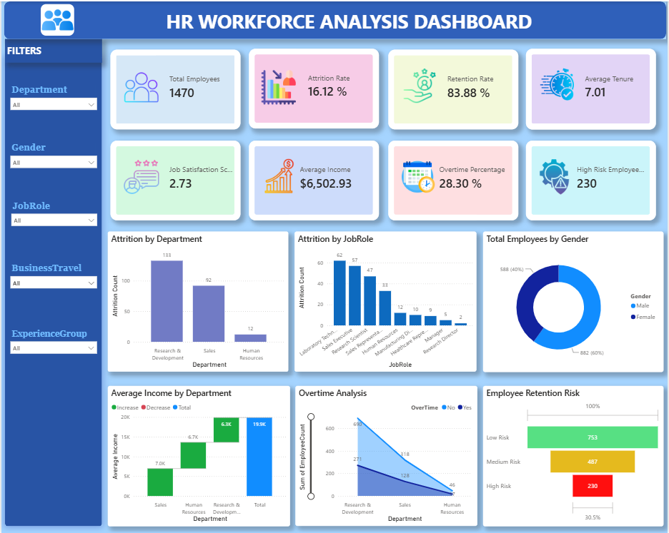

PHASE -2
- Which KPIs define workforce health?
A: Attrition Rate, Retention Rate, Job Satisfaction Score, and Overtime % — together they show if employees are stable, happy, and not overworked.
- Which metrics help HR teams?
A: High-Risk Employee Count and Average Tenure — they tell HR who to act on and how urgently.
PHASE-3
- Which factors drive employee exits?
A: Mainly overtime, low satisfaction, and poor work-life balance.
- Which employee groups are high risk?
A: Employees with low satisfaction + overtime + poor work-life balance, especially in early tenure (1–3 years).
- Which departments struggle most?
A: Usually the departments with the highest workload or lowest average satisfaction — identified directly from the data.

Business Questions :
- Which factors contribute most to attrition?
Overtime, low job satisfaction, and poor work-life balance.
- Which departments have highest turnover?
The department(s) with the most overtime and lowest satisfaction scores.
- How does work-life balance affect retention?
Poor work-life balance strongly increases the chance an employee leaves, especially when combined with overtime.
- Which employees are at highest risk?
Those flagged by the Retention Risk Score — low satisfaction + overtime + poor balance, usually in their first few years.
5. What actions should HR leadership prioritize?
- Reduce overtime in high-risk departments
- Check in with flagged high-risk employees early
- Support new employees more in their first 1–3 years
- Track these KPIs every quarter, not just once
APPENDIX: PROJECT INFORMATION

Dataset Description :
The dataset contains employee information collected from the IBM HR Analytics Employee Attrition Dataset. It includes demographic details, employment history, job-related information, compensation, performance metrics, job satisfaction, work-life balance, overtime status, and employee attrition details. The dataset is used to analyze workforce behavior, identify the factors influencing employee attrition, and support data-driven HR decision-making.
Key Dataset Attributes
- Employee ID
- Age
- Gender
- Department
- Job Role
- Monthly Income
- Total Working Years
- Years at Company
- Job Satisfaction
- Environment Satisfaction
- Work-Life Balance
- Overtime Status
- Performance Rating
- Attrition Status
- Education Level
- Marital Status
- Business Travel
- Distance From Home
Project Objectives

- Analyze employee attrition patterns across the organization.
- Perform data cleaning and preprocessing for workforce analytics.
- Create workforce Key Performance Indicators (KPIs).
- Identify factors influencing employee attrition.
- Analyze the relationship between salary, overtime, work-life balance,and job satisfaction.
- Segment employees into different workforce categories.
- Develop an interactive Power BI dashboard for HR analytics.
- Generate actionable recommendations to improve employee retention and workforce performance.

Dashboard KPIs
- Total Employees
- Active Employees
- Attrition Count
- Attrition Rate
- Employee Retention Rate
- Average Employee Age
- Average Employee Experience
- Average Monthly Income
- Job Satisfaction Score
- Overtime Percentage
- High-Risk Employee Count

Dashboard Tools & Visualizations
- KPI Cards
- Bar Charts
- Column Charts
- Heatmaps
- Trend Charts
- Funnel Charts
- Department-wise Analysis
- Salary Band Analysis
- Job Role Analysis
- Age Group Analysis
- Gender-wise Analysis
- Attrition Analysis

Recommended next steps for leadership:

- Launch immediate check-ins with employees flagged as "High Risk"
- Review overtime policy in the highest-attrition departments
- Introduce structured onboarding/mentorship support for employees in their first 1–3 years
- Re-run this analysis quarterly to track whether interventions are actually reducing attrition

CONCLUSION

- Attrition isn't random — it's driven by identifiable factors. With this dashboard, HR moves from reacting after people quit to catching risk early and acting before they leave.

